Ex:No: 16
HIGH LEVEL PROGRAMMING EXTENSIONS - PROCEDURES
Aim:
To implement procedures using program in MySQL.

Problem 1:
Create a simple procedure to get all the records from the table ‘student_info’.
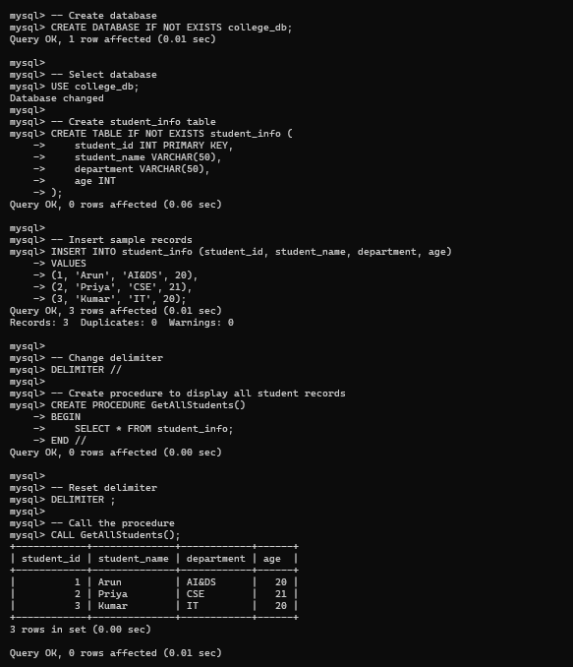
Problem 2:

Create a stored procedure GetCustomerLevel() that accepts two parameters customer number and customer level.
• First, it gets the credit limit from the customers table.
• Then, based on the credit limit, it determines the customer level: PLATINUM, GOLD, and SILVER. • The parameter p_customerlevel stores the level of the customer and is used by the calling program. The following flowchart demonstrates the logic of determining customer level.
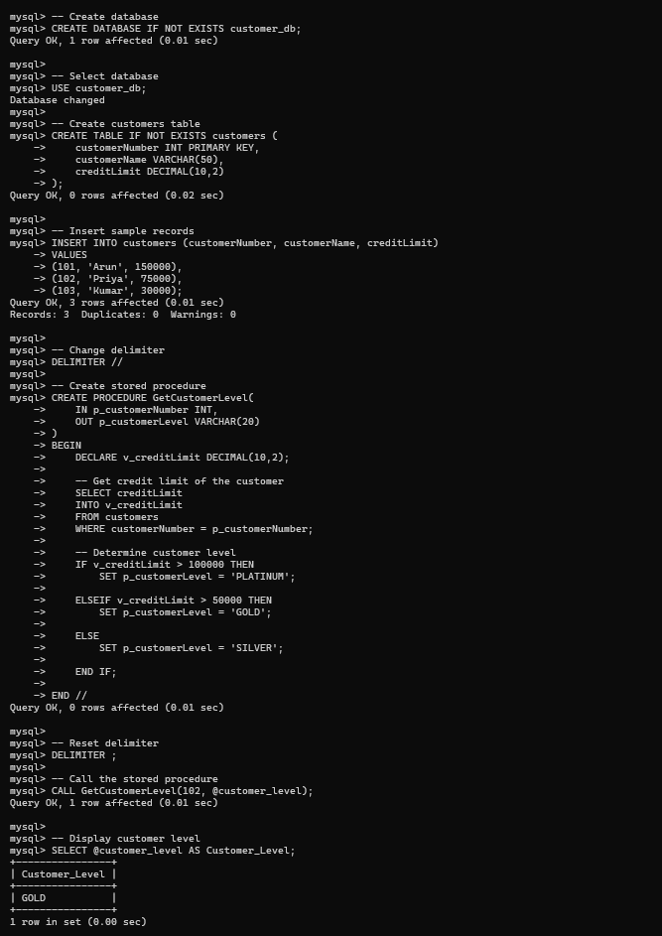
RESULT:
Thus the high level procedures programsare executed successfully.

